1. **NSN COLLEGE OF ENGINEERING AND TECHNOLOGY-GROUP 4**

**PUBLIC TRANSPORTATION AND OPTIMIZATION**

**TEAM MEMBERS**

|  |  |  |  |
| --- | --- | --- | --- |
| **S.NO** | **NAME** | **DEPRT** | **MENTOR NAME** |
| 1 | Janakidevi R | CSE | MRS D.Shanthi Priya AP/CSE |
| 2 | Ranjitha M | CSE |
| 3 | Thavasimani S | CSE |
| 4 | Rejiya Sulthana N | CSE |
| 5 | Astalaksmi S M | CSE |

**PROBLEM STATEMENT**

Today's public transportation systems, especially in large cities, face many challenges. Some common challenges of the public transportation systems surge in passengers the are number a of and transportation costs, continuous driver shortage due to caused regulations an by income decrease hours-of-service limiting the and number of miles drivers can drive, and increasing demand for real- time reporting for improving efficiency and service levels. Moreover, the main reasons for many complaints about public transportation in many transportation systems are delays. When a vehicle is delayed, not only its passengers will reach their destination with delay, but also, they may miss their connection bus or train even when small delays occur. Pub transportation managers shou focus on customers' convenience focus on customers' convenience by analyzing the roots of these issues and efficient transportation planning to avoid them as much as possible.

Transportation planning is a very complicated problem because planners must take into account multiple competing criteria (e.g., service utilization, workload requirements, cost asset minimization, fairness, etc.), components of the transportation system, and their interconnection. Moreover, transportation planners should consider many factors to create efficient plans, including but not limited to vehicle a driver availability, vehicle size a capacity, traffic details, travel time capacity, traffic details, travel time windows, and passengers' locations, which are too many for one to handle efficiently in his head. On the other hand, plans often are required to be modified later due to unexpected events, such as vehicle drivers' sickness, breakdown, and severe weather conditions, which make transportation planning even more complex. However, many transportation planners still create their transportation plans manually without using any tool that is equipped with advanced technologies, which is very hard and time-consuming for even the most experienced planners. Besides, increasing demand for faster planning, increasing pressure to reduce transportatio costs through better making, decis And increasing complexity of transportation problems due to a significant increase in transportation the size networks of make manual transportation planning almost impossible.

**BLOCK DIAGRAM**

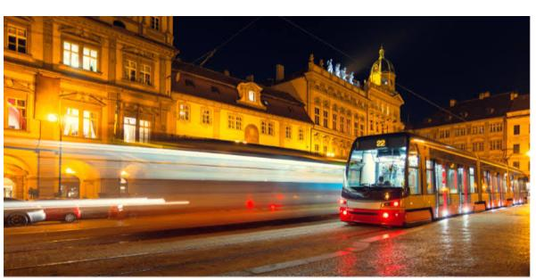

**FLOW CHART**

